The Australian Arid Lands Botanic Garden

Copyright Flinders View Primary School © All rights reserved. Permission granted only to reproduce relevant sections for classroom use.
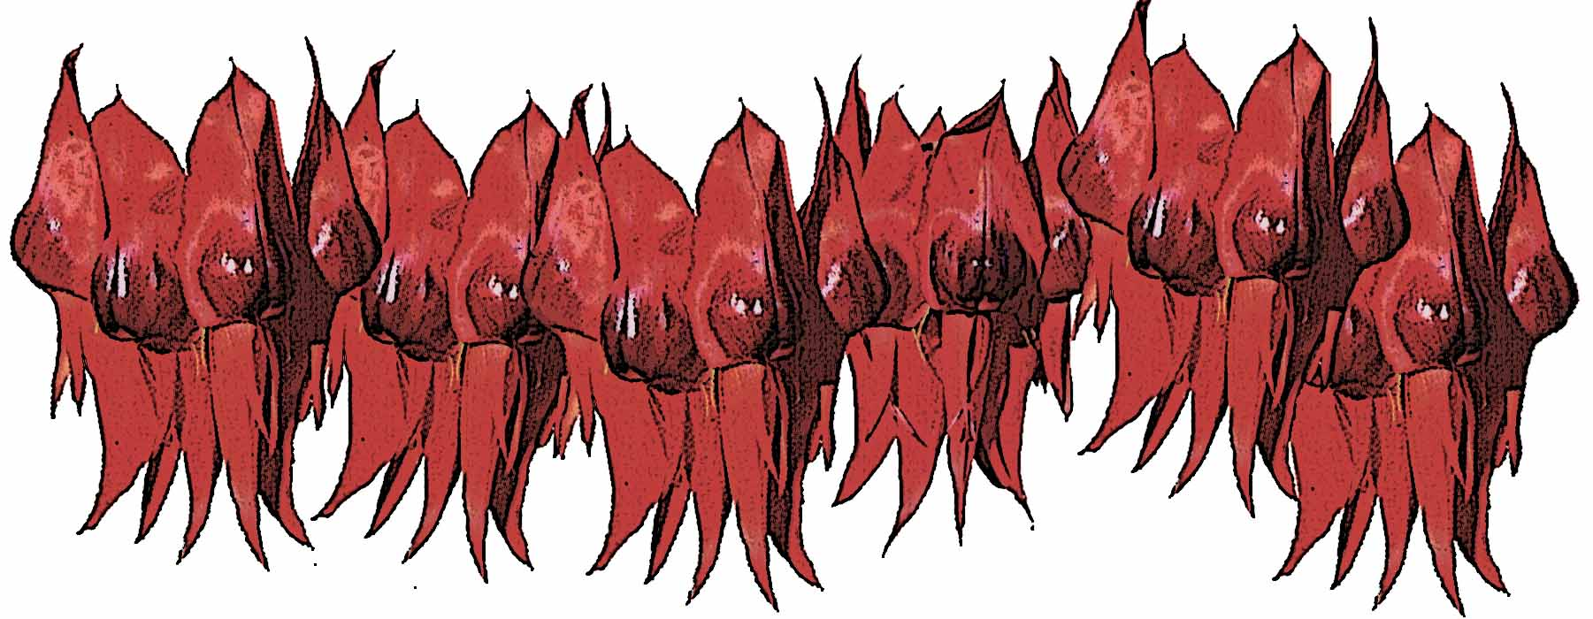
A teaching program that links The National Statements and Profiles and The Key Competencies to The Australian Arid Lands Botanic Garden.
Devised by The Special Interest Group in Planning and Programming,
Flinders View Primary School, Port Augusta.
1999

Tourism
Propagation
Biological Names
Arid Zones of Australia
Important Economic Species
Links with other similar gardens
How Aboriginal People Use Plants
Plants that are used for shade and shelter
Plants that are relevant to the Pastoral Industry
Efficient use of irrigation for arid zones and elsewhere.
The influence of arid lands climate on Aboriginal Culture
Land use in the North of South Australia over the last 200 years
Use of technologies at the Australian Arid Lands BOTANIC Garden

Friends and sponsors of The Australian Arid Lands BOTANIC Garden

Energy and water saving features of the Australian Arid Lands BOTANIC Garden
Bush Tucker Plants

Ornamental Plants

Medicinal Plants

Mangroves

Vermin
Land Rehabilitation
Arid Zones Ecosystems

Identify different shaped leaves.
Draw the shapes of clouds.
Observe the weather.
Discuss what happens when the wind blows.
Look for dead and living things.
Find people who work at The Australian Arid Lands Botanic Garden.
Discuss the work people do.
Observe how animals move.
Use adjectives to describe plants and animals.
Draw things you can hear or smell.
Describe the signs and labels at The AALBG.
Draw the lights and discuss interesting features.
Investigate how plants obtain water.
Ask questions to find out which plants are wild and which people have planted.
Find a range of walking surfaces.
Name the colours of flowers.
Describe how the colours of leaves vary.
Find natural and man made things.
Describe the differences between car numberplates (in the car park).
Observe different birds and describe their similarities and differences.
Investigate animals, reptiles, spiders and insects.
Look for signs relating to dangerous animals.
Describe what actions should be taken if you observe a dangerous snake or spider.
Ask someone to explain what plant is the emblem of The Australian Arid Lands Botanic Garden.
Investigate why there are dead trees near the little pond.
Investigate what things animals need to survive.
Discuss the purpose of the “Donation Box”

The Australian Arid Lands Botanic Garden PLACE AND SPACE BAND B

Significant Features

Before the visit….. | Equipment
INVESTIGATE, DISCUSS, EXAMINE..  - The kinds of features that might be found at The Australian Arid Lands Botanic Garden  - Devise a list of rules to follow at the visit.  - Discuss the Bingo lists included in this program.  - Investigate the BOTANIC names of plants and why some plants are precious.  - Investigate who might be involved in caring and supporting The Australian Arid Lands Botanic Garden and how this is done. | - Paper  - Pencils  - Camera  - Video  - List
AT The Australian Arid Lands Botanic Garden | S & P Outcomes
- Explore  - Follow the rules  - Interview - Ask questions- collect information find out about the people behind The Australian Arid Lands Botanic Garden Take Photographs,  - Video people talking about the plants and other aspects of the AALBG.  - Draw pictures and diagrams.  - Use the “Bingo” lists included with this program  - Investigate history and plans for the future | 3.5  3.6  4.4  4.5  4.6
Following the visit | Links with Key Competencies
- Describe how The Australian Arid Lands Botanic Garden might change in the future and explain why.  - Categorise, display and discuss samples, drawings, and pictures.  - Describe how the natural and man made features of the AALBG are unique.  - Explain how man made aspects of the gardens assist plants to survive in an arid region.  - Compare the AALBG with other parts of the world.  - Design a survey to find a range of viewpoints relating to people’s opinions and use of The Garden.  - Describe how people who value conservation are committed to caring for plants at The AALBG.  - Create an advertising campaign to overcome any negative perceptions people have of the AALBG. | K C 1  KC 4  KC 7

The Australian Arid Lands Botanic Garden PLACE & SPACE BAND A-B

MAPPING

Before the visit….. | Equipment
INVESTIGATE, DISCUSS, EXAMINE.  - Features of maps  - Keys, legends, roads, paths,  Man made features, Natural features  - Distinctive Australian Landscapes  - Climates, Types of plants  - World locations  - LOCATION OF AALBG using map/ Atlas.  - Making own maps  - Planning, deciding what may need to be included, materials needed etc. | - Copy of map  - Pencils  - Rulers  - Erasers  - Highlighters
AT _ The Australian Arid Lands Botanic Garden | S & P Outcomes
- Make your own map showing your journey through the AALBG.  - Use a map of the Australian Arid Lands Botanical Garden.  - Locate and Mark natural and man made features.  - Locate and mark bush tucker (eatable) plants.  - Locate and mark interesting plants, trees, etc. | 2.4  3.4  4.4
Following the visit | Links with Key Competencies
- Use maps to explain the features of the AALBG.  - Interpret a map of the AALBG using symbols to locate points of interest..  - Evaluate how informative or effective the maps are.  - Discuss ways of improving maps. | KC 3  KC 5  KC 2:

The Australian Arid Lands Botanic Garden PLACE AND SPACE BAND A

Investigate The Natural and Man Made Features of The AALBG

Before the visit….. | Equipment
INVESTIGATE, DISCUSS, EXAMINE..  - Natural and man made things  - Make a list of the types of things that may be found at the AALBG.  - Discuss the Bingo lists included in this program.  - Make a list of rules to follow on the visit. | - Paper  - Pencils  - Camera  - Video  - List
At The Australian Arid Lands BOTANIC Garden | S & P Outcomes
- Explore  - Ask questions  - Follow the rules  - Take Photographs,  - Use video.  - Draw pictures, diagrams.  - Use the “Bingo” lists included with this program | 1.5  1.6  2.4  2.5  2.6
Following the visit | Links with Key Competencies
- Collate drawings, photos etc.  - Categorise, display and discuss samples, drawings, pictures.  - Describe the natural and man made features of the AALBG.  - Discuss some of the purposes of the man made aspects of the gardens.  - Give reasons why The Australian Arid Lands Botanic Garden is a special place.  - Explain how people look after the AALBG  - Discuss how we look after other gardens eg. the school’s | K C 1  KC 4  KC 7

The Australian Arid Lands Botanic Garden NATURAL & SOCIAL SYSTEMS BAND A

Investigate Natural and Social Systems

Before the visit….. | Equipment
INVESTIGATE, DISCUSS, EXAMINE..  - The importance of the land to Aboriginal people  - The habitats of different animals.  - Methods of recording information. | - Paper  - Pens / pencils  - Camera  - Video
At----The Australian Arid Lands Botanic Garden | S & P Outcomes
- List plants, animals, insects etc.  - Find plants that are used for food or shelter  - Investigate how plants and trees support the lives of creatures at the AALBG.  - Record this information in some way | 1 .13  2.13  3.13
Following the visit | Links with Key Competencies
- Display / Explain findings using drawings, charts, written information, photos, video  - Explain why the AALBG is important.  - Explain why plants are important to Aboriginal people.  - Describe how trees/ plants at AALBG support the lives of animals, using drawings and diagrams.  - Describe what would happen if one element E.G. water was removed from the garden. | KC 1  KC 2  KC 4:  KC 7

The Australian Arid Lands Botanic Garden PLACE AND SPACE BAND A

Investigate The AALBG using the senses.

Before the visit….. | Equipment
INVESTIGATE, DISCUSS, EXAMINE..  - What is a GARDEN?  - Where do we find gardens?  - Find and display pictures of gardens.  - Make a list of words to describe gardens. | - Paper  - Pencils  - Paper bags  - Camera  - Audio tape
The Australian Arid Lands BOTANIC Garden | S & P Outcomes
- Explore the AALBG and gather information using - The senses of SIGHT, TOUCH, SMELL. HEARING, TASTE.
- Collect examples if allowed.
- Make a list of words that describe The Arid Lands Experience.
- Draw pictures and diagrams.
- Take photos and tape sounds.

Following the visit | Links with Key Competencies
- Collate drawings, samples etc.  - Categorise, display and discuss samples, drawings, and pictures.  - Identify / Discuss/ Present photos, audio sounds.  - Compare lists of words, talk about similarities and differences. | K C 1  KC 4  KC 7

The Australian Arid Lands Botanic Garden NATURAL & SOCIAL SYSTEMS BAND B

Systems

Before the visit….. | Equipment
INVESTIGATE, DISCUSS, EXAMINE..  - Ecosystems  - Water cycle  - Solar Power  - Conservation  - Effects of farming on ecosystems | - Paper  - Pens / pencils  - Camera  - Video
The Australian Arid Lands Botanic Garden | S & P Outcomes
- Investigate how plants and animals or insects at The Australian Arid Lands Botanic Garden are linked by a food chain.  - Investigate the watering system at The Australian Arid Lands BOTANIC Garden Interview / ask questions to determine how plants are able to survive bushfires, drought, etc. | 3.13  4.13
Following the visit | Links with Key Competencies
- Draw a diagram to show an example of how plants and animals or insects at The Australian Arid Lands Botanic Garden are linked by a food chain.  - Describe how farming can effect ecosystems.  - Present an argument for The Australian Arid Lands Botanic Garden to – “receive increased Government Grants to provide further development.” | KC 1  KC 2  KC 4:  KC 7

BINGO
Guides at “The Australian Arid Lands Botanic Garden” are volunteers who have a specific knowledge of plants and other features of the garden.  This list may be used when working with a guide and will give the guide an indication of the information your group is seeking. | a bird | a leaf | an ant | a flowering bush
Keep your eyes and ears open, listen carefully to the guide, tick or colour the box when you discover one of the things named in the boxes.  BINGO   | a tree | long grass | a smelly plant | a spiky  bush
Call out BINGO when you find all the items.  Or see who can find the most. | A plant you can eat. | a yellow flower | a pink flower | a bee or a fly

Guides at “The Australian Arid Lands Botanic Garden” are volunteers who have a specific knowledge of plants and other features of the garden.  BINGO | saltbush | mistletoe | Eucalypt | a flowering bush
This list may be used when working with a guide and will give the guide an indication of the information your group is seeking. | Sturt’s desert pea | Lemon grass | Curry plant | Pigface
BINGO   | A plant you can eat. | Eremophila | Wattle | 3 different insects
Keep your Eyes and ears open, listen carefully to the guide, tick or colour the box when you find the object …….. Play the BINGO game. | different birds | A rattling seedpod | The Emu bush | Western myall  200+ years old
Call out BINGO when you find all the items.  Or see who can find the most in your group. | Poached egg daisy | Umbrella bush | Fruit salad tree | Flannel bush  Poisonous

Guides at “The Australian Arid Lands Botanic Garden” are volunteers who have a specific knowledge of plants and other features of the garden.  BINGO | Tetragonia eremaea  ( Native Spinach) | *Mesembrianthemum  family of plants  (Pig Face) | Atriplex Family of plants  ( Saltbush)
This list may be used when working with a guide and will give the guide an indication of the information your group is seeking. | Sturt’s desert pea | Maireana family of plants  (Bluebush) | Calocephalus platycephalus  ( Billy buttons)
BINGO   | Senecio minimus  (Shrubby fire wheel ) | Convolvultus remotus  ( Australian bindweed) | Dactyloctenium radulans  (Button grass)
Keep your Eyes and ears open, listen carefully to the guide, tick or colour the box when you find the plants to play the BINGO game. | Acacia oswaldii  ( Umbrella wattle) | Acacia papyrocarpa  ( Western myall) | Amyema preissii  (Wire leaved mistletoe)
Call out BINGO when you find all the items.  Or see who can find the most in your group. | Solanum petrophilum  (Prickly nightshade) | *Echium plantagineum  (Pattersons curse) | Avena fatua  ( Wild oats)

* Introduced Species

Guides at “The Australian Arid Lands Botanic Garden” are volunteers who have a specific knowledge of plants and other features of the garden.  BINGO | Callitris glaucophylla  (White cyprus pine) | Allocasuarina verticillata  ( Drooping sheoak) | Santalum lanceolatum  (Quandong)  Wild peach
This list may be used when working with a guide and will give the guide an indication of the information your group is seeking. | Santalum spicatum  (Sandalwood) | Atriplex semibaccata  (Berry saltbush) | Capparis mitchellii  (Native orange)
BINGO   | Pittosporum phylliraeoides var, microcarpa  (Native apricot) | Acacia pycnantha  (Golden Wattle) | Swainsona formosa  (Sturts desert pea)
Keep your Eyes and ears open, listen carefully to the guide, tick or colour the boxes as you find the plants to play the BINGO game. | Acacia oswaldii  (Umbrella wattle) | Acacia papyrocarpa  (Western myall) | Alyogyne huegelii  (Lilac hibiscus)
Call out BINGO when you find all the items.  Or see who can find the most in your group. | Solanum lasiophyllum  (Flannel Bush) | Callistemon teretifolius  (Flinders Ranges bottlebrush) | Gossypium sturtianum  (Sturts desert rose)

Map of The Australian Arid Lands Botanic Garden | Draw Connecting lines to label the map
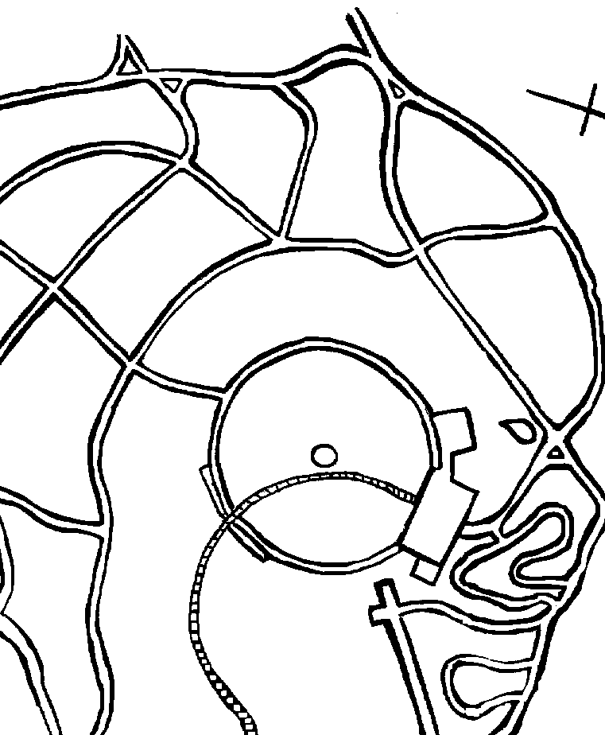 | - The Main Building  - The Sun Dial  - The Arch  - The Eremophila Garden  - The curved path  - The Main Entrance  - Clump of Western myall  - Blue bush  - Bottle brush bush  - Water Hole  - The Car park  - Water tanks  - Sturt’s desert pea  - Saltbush

